Forest biomass carbon inventory of the Parque Nacional Cordillera Azul (PNCAZ)

David Shoch
Jedi Rosero
Víctor Barrena
Marlon Ortega
Scott Settelmyer

Prepared for The Field Museum
Updated November 2012

Forest Carbon Inventory Sampling Design
The objective of the inventory was to estimate biomass carbon stocks for the project area with a 95% confidence interval within 10% of the mean. The inventory was designed to produce precise estimates of carbon stocks, not changes in carbon stocks (i.e., the project assumes stable forest carbon stocks because the forest is a mature, primary forest). Measured pools included above and belowground live tree biomass and standing and lying dead wood. The inventory area was delineated on the basis of an initial risk assessment by CIMA, and includes four major forest strata: Alluvial Forests, Hill Forests, Mountain Forests, and Mauritia palm swamps (Aguajales). The sampling plan employed stratified, random, cluster sampling. Clusters were made up of five temporary point samples using wedge prisms (20 and 40 ft²/acre Basal Area Factor). Lying dead wood was sampled using line intersect sampling (100 m per sample point). Field measurement procedures are detailed in Appendix 2.

Required sample size calculations and results are summarized below. Preliminary estimates of biomass stocks and variance were based on data from Peruvian Amazon sites (i.e., terra firme and seasonally flooded forests) from Malhi et al. 2006, volume data from a range of forest types in Peru published by Malleux Orjeda (1981), and from a forest inventory of a nearby site in Pucallpa, Peru (Victor Barrena, unpublished data).

Required sampling intensity was determined using the equation below for stratified random sampling with optimum allocation (Avery and Burkhart 1994)

Where,
n required sampling intensity
E allowable error (i.e., desired half-width of the confidence interval)
t sample statistic from the t-distribution for the 95 % confidence level (set at 2.042)
L number of strata
N number of sampling units in the population
N_{h} number of units in strata h
s_{h} standard deviation in strata h
s²_{h} variance in strata h.

Sample units (i.e., cluster centers) were allocated optimally (per Avery and Burkhart 1994) among component strata, with calculated allocations rounded up to the nearest integer. The sampling intensity was increased by 10% (with a minimum of 5 plots in any one strata) as a contingency measure to ensure that precision targets were met (Table 1). Cluster centers were then randomly located within strata (Figure 1).

Table 1: Sample size calculation for PNCAZ forest inventory
 | Alluvial forest | Hill forest | Mountain forest | Aguajal | Total
Area (hectares) | 48,293 | 238,874 | 293,531 | 8,244 | 588,942
Anticipated mean (t C/ha) | 150 | 170 | 100 | 80
Weighted mean |  |  |  |  | 132.2
Estimated variance | 1901.3 | 2080.8 | 500.0 | 115.2
Estimated standard deviation | 43.6 | 45.6 | 22.4 | 10.7
Estimated coefficient of variation | 29% | 27% | 22% | 13%
Sample size* (stratified with optimum allocation among strata) | 5.9 | 30.5 | 18.4 | 0.2 | 55.0
FINAL SAMPLE SIZE | 6 | 33 | 20 | 5 | 64

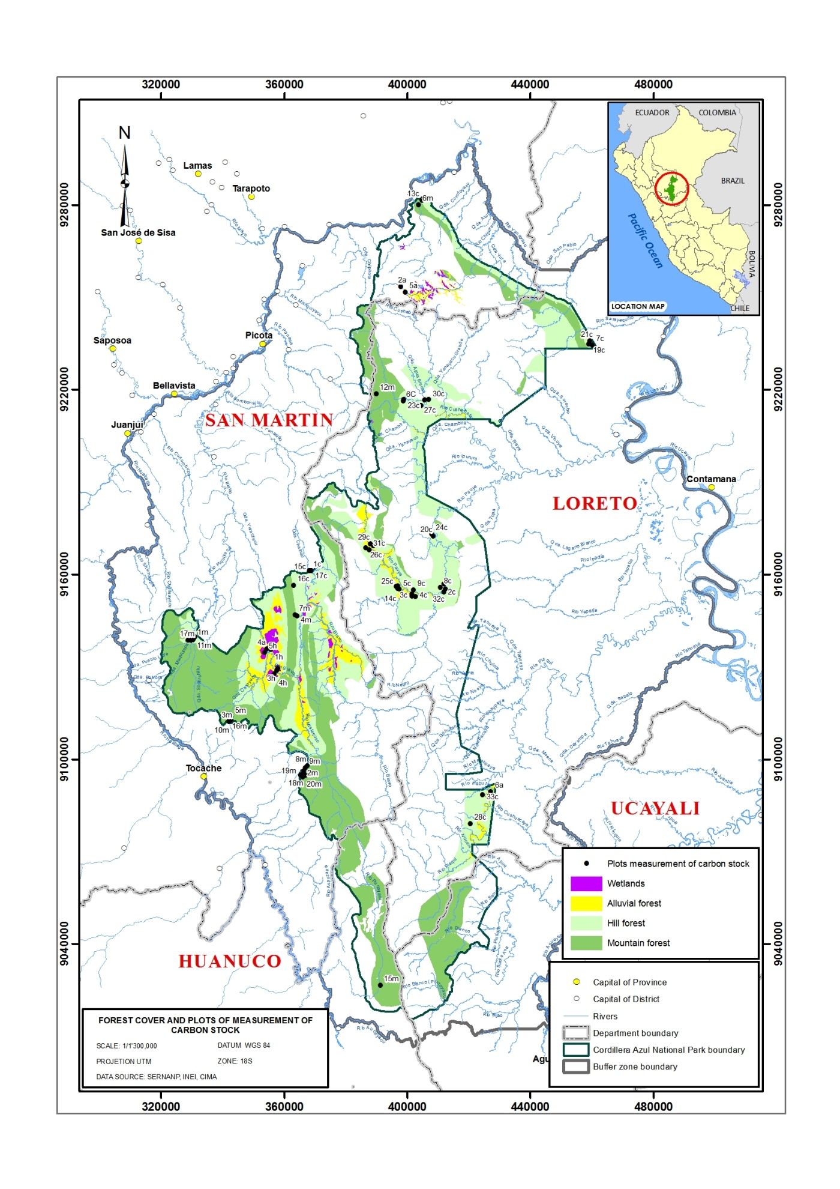
Figure 1. Location of sample points (cluster centers) in the PNCAZ inventory area.

Field Implementation
Field work took place from 6 August to 9 December 2009 for a total effort of over 900 people-days. The work was carried out in the field by PNCAZ park guards under the leadership of forester Jedi Rosero with ongoing guidance during implementation from David Shoch and Victor Barrena, all of whom hold advanced degrees in forestry and forest science and many years of experience in tropical forest inventory. Standard field protocols, including quality control measures, are detailed in full in Appendix 2.

Field crews were fully trained in all aspects of the field data collection during the field training conducted in the northwest sector of the PNCAZ from 2-5 August 2009. Pilot sample points were used during the field training prior to initiating formal measurements to appraise field crews and identify and correct any errors in field measurements. Subsequent trainings (prior to each field entry) were held periodically throughout the implementation.
Crews adhered to field measurement protocols outlined in Appendix 2. Field crew leaders were responsible for ensuring that field protocols were followed to ensure accurate and consistent measurement. During implementation, an opportunistic sample of points was re-measured to determine measurement error.
Field measurement data were recorded on standard field data sheets (included in Appendix 2). Data were entered from field sheets to the database template “entrada de datos PNCAZ inventario.xls.” Checks were run for unusual (high or low) values to identify and correct any errors in recorded field data or transcription. Personnel involved in data analysis consulted with personnel involved in measurement to clarify any ambiguities in recorded field data.
On each return from the field, field data sheets were photocopied and originals archived with the CIMA office in Tarapoto.

Forest Carbon Inventory Data Analyses

Live Trees
For live trees, biomass was calculated as a function of diameter at breast height (DBH; in cm) using the predictive model developed by Chave et al. 2005 for tropical wet forest stands,

$AGB=WD* e^{-1.239+1.980*LN\left(DBH\right)+0.207*{LN(DBH)}^{2}-0.0281*{LN(DBH)}^{3}}$

where,
AGB Aboveground live tree biomass (kg)
WD Wood density (g/cm³)
DBH Diameter at breast height (cm)

Application of the “wet” equation (i.e., > 3500mm annual precipitation) reflects the weighted average annual precipitation for the inventoried area of PNCAZ of 4,400 mm. Calculations applied the species level mean wood density for Amazonian forests, 0.62 g/cm³, calculated by Baker et al. (2004) and subsequently validated for western Amazonia by Anderson et al. (2009).
Because no verifiable biomass equations for
genera in the Cecropiaceae family (Pourouma spp and Cecropia spp) were available, these trees were conservatively ignored in biomass calculations (i.e. stems assigned biomass of zero).

AGB=12.764+0.2588* DBH2.0515

For palms, calculations used height and basal diameter measurements to estimate the aboveground volume of a paraboloid and then applied mean (species level) Amazonian palm specific gravity of 0.31 g/cm³ estimated by Baker et al. (2004). The estimate of biomass was therefore limited to the main trunk (bole) of the palm. Thus, for palms, the equation below was used.

$AGB=0.5*π*{(\frac{BD}{200})}^{2}*H*WD$

where
AGB Aboveground live tree biomass (1000 kg)
BD Basal diameter (cm)
H Stem height (m)
WD Wood density (g/cm³)
$B\text{SDWl,sp,i,t<td}= \frac{1}{3}*π* {\left(\frac{BD\text{SDWl,sp,i,t<td}}{200}\right)}^{2}*H\text{SDWl,sp,i,t<td}* D\text{DW,dc}$
For Aguajal palm (Mauritia flexuosa), calculations used the biomass equation and carbon fraction of biomass (0.48633) from Freitas et al. (2006; incorporating mean 0.276 root:total biomass ratio, from Freitas et al. 2006, to adapt total biomass equation to aboveground biomass only),

$AGB=\left(1-0.276\right)*-0.00006*H^{3}+0.0046*H^{2}-0.043*H+0.1259$

where
AGB Aboveground live tree biomass (1000 kg)
H Stem height (m)

Root Biomass
Root biomass density was estimated at the cluster sample level applying the equation developed by Cairns et al. (1997; R-squared=0.83),

$R= e^{-1.085+0.925*LN(AGBD)}$

Where
R Root biomass density (1000 kg/ha)
AGBD Aboveground biomass density (1000 kg/ha)

Dead Wood
The volume of lying dead wood per unit area was estimated using the equation (Warren and Olsen 1964) as modified by Van Wagner (1968) separately for each dead wood density class

where
V_{LDW} Volume of lying dead wood per unit area( m³ /ha)
D_{n} Diameter of piece n of dead wood along the transect (cm)
N Total number of wood pieces intersecting the transect
L Length of the transect (m)

Length of transect was corrected for slope. The volumes per unit area of each dead wood density class were then multiplied by their respective densities to convert to a mass per unit area.

Biomass of standing dead wood was estimated using the allometric equation for live trees in the decomposition class 1. In decomposition class 2, the estimate of biomass was limited to the main trunk (bole) of the tree, in which case the biomass was calculated converting volume to biomass using the intermediate dead wood density class. Volume was estimated as the volume of a paraboloid.

Density of dead wood was determined through sampling and laboratory analysis as follows. Discs were collected in the field and decomposition class and green volume determined as per standard protocols (Appendix 2). Discs were then transferred to a laboratory (Laboratorio de Análisis de Suelos del Instituto Nacional de Investigación Agraria, INIA) in Tarapoto and oven-dried at 80°C, conducting continuous weight measurements until reaching constant weight. The resulting dry weight was recorded and used to calculate dead wood density as oven-dry weight (g) / green volume (cm³) for each sample.

All biomass values, except those for Mauritia, for which species-specific values were available from the study region, were converted to carbon fraction using the coefficient of 0.47, as recommended by the Guidelines for National Greenhouse Gas Inventories (IPCC 2006).

All data and calculations are available for review in the spreadsheet entitled “PNCAZ inventory analysis” maintained by CIMA.

Results
Results of dead wood specific gravity analysis, assessment of measurements error, and forest biomass carbon estimates are elaborated in the following tables. The raw data are included in Appendix 1.

Table 2: Results of dead wood density measurements, expressed in g/ cm³

Statistic | Wood Density per Decomposition Class (g/cm³)
Statistic | Solid | Intermediate | Rotten
Mean | 0.54 | 0.38 | 0.25
Variance | 0.02 | 0.01 | 0.01
Standard Deviation | 0.14 | 0.11 | 0.12
Coefficient of Variation (%) | 25.86 | 28.56 | 47.52
Standard Error | 0.03 | 0.02 | 0.02
90% Confidence Interval | 0.04 | 0.03 | 0.04
95% Confidence Interval | 0.05 | 0.04 | 0.04
Number of Samples | 30 | 30 | 30

On average, live aboveground biomass, live belowground biomass, standing dead wood and lying dead wood made up 75%, 18%, 1% and 6%, respectively, of total forest carbon (combined pools measured or calculated).

Table 3: Forest carbon density estimates and statistics by forest type/strata

 | Live and Dead Above and Belowground Biomass C (t C/ha)
Statistic | Alluvial Forests | Hill Forests | Mountain Forests | Aguajales
Mean | 80.5 | 127.3 | 183.2 | 101.8
Variance | 466.8 | 726.5 | 2264.9 | 497.8
Standard Deviation | 21.6 | 27.0 | 47.6 | 22.3
Coefficient of Variation (%) | 26.8 | 21.2 | 26.0 | 21.9
Standard Error | 8.8 | 4.7 | 10.6 | 10.0
90% Confidence Interval | 17.8 | 8.0 | 18.4 | 21.3
95% Confidence Interval | 22.7 | 9.6 | 22.3 | 27.7
Number of Samples | 6 | 33 | 20 | 5

Per the VCS REDD methodology VM0007, confidence deductions are applied where uncertainty exceeds +/- 15% of the mean at a 95% confidence level. This precision requirement is met for both aboveground biomass and for total forest biomass, including belowground and dead wood (Tables 4 and 5).
Note that error was not propagated across pools, because error propagation formulas require independence among component sources of error. This assumption often does not hold for aboveground biomass and dead wood, which are often inversely correlated, and instead pools are summed and composite errors estimated at the strata level, then propagated across strata.

Table 4: Overall aboveground live tree biomass carbon density estimate and statistics

Mean Forest Carbon Density (t C/ha) | 113.8
Standard Error (t C/ha) | 4.8
90% Confidence Interval (t C/ha) | 8.0
95% Confidence Interval (t C/ha) | 9.6
90% Confidence Interval as percentage of mean | 7.1%
95% Confidence Interval as percentage of mean | 8.4%

Table 5: Overall forest carbon density (live and dead above and belowground biomass C) estimate and statistics

Mean Forest Carbon Density (t C/ha) | 151.0
Standard Error (t C/ha) | 5.68
90% Confidence Interval (t C/ha) | 9.5
95% Confidence Interval (t C/ha) | 11.4
90% Confidence Interval as percentage of mean | 6.3%
95% Confidence Interval as percentage of mean | 7.5%

Measurement error assessment

As explained in the field procedures in Appendix 2, field crews were instructed to measure any borderline trees, even in cases of the slightest doubt. On average, crews encountered and measured 1.2 borderline trees per point (5.9 per cluster).
Live tree biomass was remeasured on 18 sample points during the inventory to assess measurement error. Points were selected for remeasurement opportunistically. The percent difference in aboveground biomass estimates, weighted by field entry, was 7.1% (Appendix 1). Measurement error is estimated as one half the percent difference between the actual and repeat measures (a valid assumption in this case where teams were equally experienced, as here, and provided there are no systematic errors in measurement, which could not be assessed). The measurement error is calculated to be approximately 3.6%.

Validation of Chave et al 2005 and Freitas et al 2006 allometric equations in the context of PNCAZ
Short of cost-intensive destructive sampling, accuracy of allometric equation results was assessed through a quasi-validation.
For the Chave et al 2005 equation, measurement data on 79 trees (ranging from 6-96 cm dbh) were collected from 11 point samples located in and around PNCAZ in July 2012 (using 40 BAF wedge prisms – 6 points in mountain forest, 5 points in hill forest and 5 points in alluvial forest, all located opportunistically).
Estimates of live aboveground biomass calculated using the allometric equation (with dbh as the sole independent variable) were compared with estimates of aboveground biomass (tons) calculated as follows, which served as the “observed” value:
Live aboveground biomass = Stem Volume * Wood Density * (1 / 0.656)
Where,
Stem volume (m3) = EXP((-9.5452)+(2.12837*(LN(DBH(cm))))+(0.72209*(LN(Commercial height(m)))))
DBH measured in the field
COMMERCIAL HEIGHT measured in the field (stem height to base of crown)
Wood Density (species-specific) = in g/cm³; Chave et al. 2006 database of wood density for species naturally occurring in Central and South America. Trees were identified and recorded in the field by local foresters familiar with the composition of the project area forest.
Where species-specific wood density was not available, average wood density for the genus or family was applied; Chave et al. 2006
Where the tree was unidentified, a wood density of 0.614 g/cm³ was applied, corresponding to the species level mean for the northwestern Amazon region; Chave et al 2006
0.656 = ratio of stem biomass : total aboveground biomass; Higuchi et al 1998, n = 315 trees from Amazonas, Brazil. This ratio, developed from regional data and thus more specific to the project site, was used instead of the pantropical biomass expansion factors provided in the REDD Modules Methodology, VM0007.
The Chave et al. (2005) for tropical wet forest stands allometric equation meets the requirements of methodology VM0007, whereby trees are distributed both above and below the curve and less than 75% of the predicted biomass estimates are above the observed values. Furthermore, regression analysis demonstrates that the slope of the line “observed” : estimated is not significantly different than 1 (95% confidence interval of the slope is 0.98 to 1.14) (Figure 2).

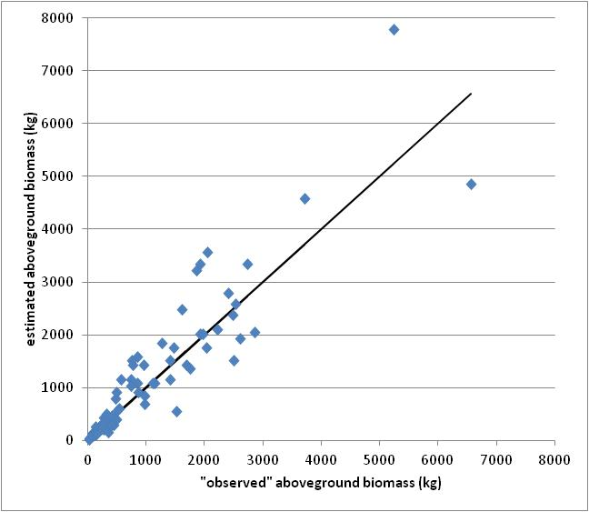
Figure 2. Estimates of live aboveground biomass: “observed” versus estimated (Chave et al 2005). Solid line = 1 : 1 line.

For the Freitas et al 2006 equation, measurement data on 80 Mauritia flexuosa palms (ranging from 2-25 m stem height) were drawn from the 2009 inventory of PNCAZ.
Estimates of live aboveground biomass calculated using the allometric equation (with stem height as the sole independent variable) were compared with estimates of aboveground biomass (tons) calculated as follows, which served as the “observed” value:
Live aboveground biomass = Stem Volume * Wood Density
Where,
Stem volume (m3) = PI * (basal diameter * (1/2) * (1/100))^2 * stem height * (1/3)
Basal diameter (cm) measured in the field
Stem height (m) measured in the field
(1/3) – analysis conservatively assumes the volume of a cone
Wood Density = in Mg/m³; mean (species level) Amazonian palm specific gravity of 0.31 g/cm³ estimated by Baker et al. (2004), note that no Mauritia flexuosa-specific wood density estimates could be found in an extensive literature search
The analysis is further conservative in that the calculated “observed” value does not include aboveground biomass in foliage.
Results (Figure 3) appear to show that the Freitas et al. (2006) allometric equation has a conservative bias. Notwithstanding, the equation should meet the requirements of methodology VM0007 in being demonstrably not non-conservative (i.e. less than 75% of the predicted biomass estimates are above the observed values).

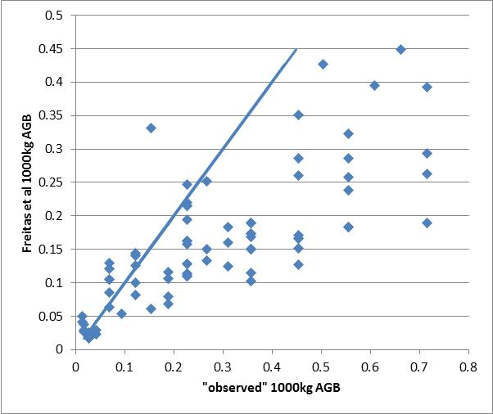
Figure 3. Estimates of live aboveground biomass of Mauritia flexuosa: “observed” versus estimated (Freitas et al 2006). Solid line = 1 : 1 line.

Appendix 1. Detailed inventory results

Location of sample clusters.
Cluster | Estrato | DATUM | UTM N | UTM E
1a | Aluvial | WGS 84 | 9128822 | 357607
2a | Aluvial | WGS 84 | 9253491 | 397776
3a | Aluvial | WGS 84 | 9153581 | 401520
4a | Aluvial | WGS 84 | 9135872 | 354243
5a | Aluvial | WGS 84 | 9251654 | 399320
6a | Aluvial | WGS 84 | 9089403 | 427114
10c | Colina | WGS 84 | 9169239 | 388994
11c | Colina | WGS 84 | 9152906 | 401507
12c | Colina | WGS 84 | 9154258 | 411849
13c | Colina | WGS 84 | 9281504 | 404728
14c | Colina | WGS 84 | 9155411 | 396808
15c | Colina | WGS 84 | 9161230 | 368429
16c | Colina | WGS 84
17c | Colina | WGS 84 | 9161248 | 368755
18c | Colina | WGS 84 | 9139793 | 330979
19c | Colina | WGS 84 | 9234834 | 458959
1c | Colina | WGS 84 | 9161179 | 368222
20c | Colina | WGS 84 | 9172390 | 408369
21c | Colina | WGS 84 | 9235848 | 459215
22c | Colina | WGS 84 | 9214833 | 404431
24c | Colina | WGS 84 | 9173098 | 407937
25c | Colina | WGS 84 | 9156182 | 396908
26c | Colina | WGS 84 | 9168623 | 386548
27c | Colina | WGS 84 | 9216603 | 405572
28c | Colina | WGS 84 | 9078975 | 420412
29c | Colina | WGS 84 | 9169944 | 387991
2c | Colina | WGS 84 | 9156864 | 411836
30c | Colina | WGS 84 | 9216825 | 406963
31c | Colina | WGS 84 | 9167901 | 387658
32c | Colina | WGS 84 | 9155231 | 412436
33c | Colina | WGS 84 | 9088492 | 424410
3c | Colina | WGS 84 | 9156055 | 396296
4c | Colina | WGS 84 | 9152794 | 402610
5c | Colina | WGS 84 | 9155271 | 397364
7c | Colina | WGS 84 | 9234403 | 460028
8c | Colina | WGS 84 | 9155825 | 410654
9c | Colina | WGS 84 | 9154880 | 401933
12m | Colina alta | WGS 84 | 9218658 | 389881
23c | Colina media | WGS 84 | 9216841 | 398786
6C | Colina media | WGS 84 | 9216349 | 398739
1h | Humedal | WGS 84 | 9135654 | 355625
2h | Humedal | WGS 84 | 9136466 | 355328
3h | Humedal | WGS 84 | 9129481 | 357883
4h | Humedal | WGS 84 | 9127725 | 356818
5h | Humedal | WGS 84 | 9134705 | 353670
10m | Montaña | WGS 84 | 9112701 | 342698
11m | Montaña | WGS 84 | 9138756 | 330325
13m | Montaña | WGS 84 | 9094698 | 366911
14m | Montaña | WGS 84 | 9138564 | 328786
15m | Montaña | WGS 84 | 90826570 | 371230
16m | Montaña | WGS 84 | 9113536 | 341834
17m | Montaña | WGS 84 | 9138568 | 329718
18m | Montaña | WGS 84 | 9095511 | 366352
19m | Montaña | WGS 84 | 9094841 | 365343
1m | Montaña | WGS 84 | 9139078 | 330587
20m | Montaña | WGS 84 | 9094305 | 366033
2m | Montaña | WGS 84 | 9096285 | 366284
3m | Montaña | WGS 84 | 9112272 | 342049
4m | Montaña | WGS 84 | 9146556 | 364209
5m | Montaña | WGS 84 | 9113679 | 342777
6m | Montaña | WGS 84 | 9280012 | 403706
7m | Montaña | WGS 84 | 9146860 | 363580
8m | Montaña | WGS 84 | 9097856 | 367490
9m | Montaña | WGS 84 | 9097210 | 366879

Results of dead wood density measurements, expressed in g/ cm³.
 | Decomposition class
 | Solid | Intermed | Rotten
 | 0.34 | 0.41 | 0.17
 | 0.46 | 0.27 | 0.31
 | 0.59 | 0.18 | 0.65
 | 0.54 | 0.34 | 0.31
 | 0.43 | 0.50 | 0.23
 | 0.55 | 0.37 | 0.32
 | 0.57 | 0.42 | 0.10
 | 0.43 | 0.30 | 0.10
 | 0.75 | 0.22 | 0.11
 | 0.30 | 0.43 | 0.19
 | 0.43 | 0.39 | 0.11
 | 0.33 | 0.32 | 0.22
 | 0.31 | 0.50 | 0.36
 | 0.73 | 0.53 | 0.26
 | 0.67 | 0.23 | 0.20
 | 0.55 | 0.23 | 0.32
 | 0.63 | 0.47 | 0.21
 | 0.70 | 0.33 | 0.21
 | 0.64 | 0.46 | 0.13
 | 0.62 | 0.27 | 0.49
 | 0.63 | 0.36 | 0.19
 | 0.40 | 0.36 | 0.29
 | 0.58 | 0.26 | 0.25
 | 0.86 | 0.59 | 0.35
 | 0.49 | 0.49 | 0.21
 | 0.61 | 0.56 | 0.28
 | 0.44 | 0.30 | 0.27
 | 0.65 | 0.48 | 0.24
 | 0.54 | 0.35 | 0.16
 | 0.43 | 0.38 | 0.15
mean | 0.54 | 0.38 | 0.25
variance | 0.02 | 0.01 | 0.01
stan dev | 0.14 | 0.11 | 0.12
CV(%) | 25.86 | 28.56 | 47.52
stan error | 0.03 | 0.02 | 0.02
90% CI | 0.04 | 0.03 | 0.04
95% CI | 0.05 | 0.04 | 0.04
n | 30 | 30 | 30

Results of forest biomass inventory detailed by cluster (each cluster composed of 5 point samples).
 |  |  |  | Above and below-ground live tree biomass C | Standing and lying dead wood | TOTAL
Forest type/strata | Cluster | UTM N | UTM E | t C/ha | t C/ha | t C/ha
Alluvial forest | 1a | 9128822 | 357607 | 81.9 | 4.9 | 86.9
Alluvial forest | 2a | 9253491 | 397776 | 90.9 | 4.4 | 95.3
Alluvial forest | 3a | 9153581 | 401520 | 108.9 | 3.3 | 112.2
Alluvial forest | 4a | 9135872 | 354243 | 45.0 | 8.2 | 53.3
Alluvial forest | 5a | 9251654 | 399320 | 48.5 | 18.4 | 66.9
Alluvial forest | 6a | 9089403 | 427114 | 61.7 | 6.8 | 68.5
Hill Forest | 10c | 9169239 | 388994 | 128.9 | 4.2 | 133.1
Hill Forest | 11c | 9152906 | 401507 | 83.5 | 5.5 | 88.9
Hill Forest | 12c | 9154258 | 411849 | 95.7 | 1.9 | 97.6
Hill Forest | 13c | 9281504 | 404728 | 147.4 | 17.1 | 164.5
Hill Forest | 14c | 9155411 | 396808 | 115.8 | 7.3 | 123.1
Hill Forest | 15c | 9161230 | 368429 | 152.1 | 14.9 | 167.0
Hill Forest | 16c | 9156394 | 363086 | 124.7 | 14.8 | 139.5
Hill Forest | 17c | 9161248 | 368755 | 97.3 | 3.1 | 100.4
Hill Forest | 18c | 9139793 | 330979 | 81.8 | 15.7 | 97.5
Hill Forest | 19c | 9234834 | 458959 | 139.2 | 2.5 | 141.7
Hill Forest | 1c | 9161179 | 368222 | 123.4 | 12.3 | 135.7
Hill Forest | 20c | 9172390 | 408369 | 156.4 | 10.4 | 166.8
Hill Forest | 21c | 9235848 | 459215 | 127.9 | 2.6 | 130.4
Hill Forest | 22c | 9214833 | 404431 | 157.8 | 10.6 | 168.4
Hill Forest | 23c | 9216841 | 398786 | 114.9 | 13.5 | 128.4
Hill Forest | 24c | 9173098 | 407937 | 145.9 | 9.4 | 155.3
Hill Forest | 25c | 9156182 | 396908 | 136.5 | 5.1 | 141.6
Hill Forest | 26c | 9168623 | 386548 | 127.7 | 4.0 | 131.7
Hill Forest | 27c | 9216603 | 405572 | 152.7 | 17.7 | 170.4
Hill Forest | 28c | 9078975 | 420412 | 120.4 | 5.2 | 125.6
Hill Forest | 29c | 9169944 | 387991 | 100.0 | 4.8 | 104.8
Hill Forest | 2c | 9156864 | 411836 | 97.6 | 14.6 | 112.3
Hill Forest | 30c | 9216825 | 406963 | 89.8 | 7.6 | 97.4
Hill Forest | 31c | 9167901 | 387658 | 115.8 | 7.1 | 122.8
Hill Forest | 32c | 9155231 | 412436 | 118.4 | 6.2 | 124.6
Hill Forest | 33c | 9088492 | 424410 | 98.6 | 5.6 | 104.1
Hill Forest | 3c | 9156055 | 396296 | 99.4 | 4.7 | 104.1
Hill Forest | 4c | 9152794 | 402610 | 74.4 | 7.9 | 82.3
Hill Forest | 5c | 9155271 | 397364 | 81.8 | 10.0 | 91.7
Hill Forest | 6C | 9216349 | 398739 | 139.3 | 16.0 | 155.4
Hill Forest | 7c | 9234403 | 460028 | 167.5 | 6.1 | 173.7
Hill Forest | 8c | 9155825 | 410654 | 107.5 | 13.5 | 121.0
Hill Forest | 9c | 9154880 | 401933 | 95.8 | 4.7 | 100.5
Aguajal | 1h | 9135654 | 355625 | 96.0 | 2.4 | 98.4
Aguajal | 2h | 9136466 | 355328 | 130.2 | 1.3 | 131.5
Aguajal | 3h | 9129481 | 357883 | 111.7 | 5.1 | 116.8
Aguajal | 4h | 9127725 | 356818 | 66.9 | 11.8 | 78.7
Aguajal | 5h | 9134705 | 353670 | 74.8 | 8.6 | 83.5
Mountain Forest | 10m | 9112701 | 342698 | 109.2 | 5.9 | 115.0
Mountain Forest | 11m | 9138756 | 330325 | 168.3 | 7.6 | 175.9
Mountain Forest | 12m | 9218658 | 389881 | 241.4 | 20.1 | 261.5
Mountain Forest | 13m | 9094698 | 366911 | 168.1 | 10.2 | 178.3
Mountain Forest | 14m | 9138564 | 328786 | 200.6 | 15.3 | 215.9
Mountain Forest | 15m | 90826570 | 371230 | 193.9 | 5.7 | 199.6
Mountain Forest | 16m | 9113536 | 341834 | 226.9 | 7.0 | 233.9
Mountain Forest | 17m | 9138568 | 329718 | 139.5 | 20.7 | 160.2
Mountain Forest | 18m | 9095511 | 366352 | 187.2 | 11.1 | 198.3
Mountain Forest | 19m | 9094841 | 365343 | 165.5 | 8.3 | 173.8
Mountain Forest | 1m | 9139078 | 330587 | 100.3 | 26.2 | 126.5
Mountain Forest | 20m | 9094305 | 366033 | 142.1 | 8.9 | 151.0
Mountain Forest | 2m | 9096285 | 366284 | 247.7 | 1.8 | 249.5
Mountain Forest | 3m | 9112272 | 342049 | 126.8 | 29.3 | 156.0
Mountain Forest | 4m | 9146556 | 364209 | 117.9 | 7.3 | 125.2
Mountain Forest | 5m | 9113679 | 342777 | 155.4 | 6.2 | 161.6
Mountain Forest | 6m | 9280012 | 403706 | 106.1 | 14.8 | 120.9
Mountain Forest | 7m | 9146860 | 363580 | 150.4 | 9.3 | 159.7
Mountain Forest | 8m | 9097856 | 367490 | 261.2 | 8.4 | 269.7
Mountain Forest | 9m | 9097210 | 366879 | 217.9 | 13.1 | 231.0

Forest carbon density (live and dead above- and belowground biomass C) estimates and statistics by forest type/strata.
 | live and dead above- and belowground biomass C (t C/ha)
 | Alluvial forest | Hill Forest | Aguajal | Mountain forest
 | 86.9 | 133.1 | 98.4 | 115.0
 | 95.3 | 88.9 | 131.5 | 175.9
 | 112.2 | 97.6 | 116.8 | 261.5
 | 53.3 | 164.5 | 78.7 | 178.3
 | 66.9 | 123.1 | 83.5 | 215.9
 | 68.5 | 167.0 |  | 199.6
 |  | 139.5 |  | 233.9
 |  | 100.4 |  | 160.2
 |  | 97.5 |  | 198.3
 |  | 141.7 |  | 173.8
 |  | 135.7 |  | 126.5
 |  | 166.8 |  | 151.0
 |  | 130.4 |  | 249.5
 |  | 168.4 |  | 156.0
 |  | 128.4 |  | 125.2
 |  | 155.3 |  | 161.6
 |  | 141.6 |  | 120.9
 |  | 131.7 |  | 159.7
 |  | 170.4 |  | 269.7
 |  | 125.6 |  | 231.0
 |  | 104.8
 |  | 112.3
 |  | 97.4
 |  | 122.8
 |  | 124.6
 |  | 104.1
 |  | 104.1
 |  | 82.3
 |  | 91.7
 |  | 155.4
 |  | 173.7
 |  | 121.0
 |  | 100.5
mean | 80.5 | 127.3 | 101.8 | 183.2
variance | 466.8 | 726.5 | 497.8 | 2264.9
stan dev | 21.6 | 27.0 | 22.3 | 47.6
CV(%) | 26.8 | 21.2 | 21.9 | 26.0
stan error | 8.8 | 4.7 | 10.0 | 10.6
90% CI | 17.8 | 8.0 | 21.3 | 18.4
95% CI | 22.7 | 9.6 | 27.7 | 22.3
n | 6 | 33 | 5 | 20

Repeat measurements of sample points and assessment of measurement error.
 |  | actual |  |  | repeated
entry (area/date) | # clusters | Cluster | Punto | AGB t C/ha | Cluster | Punto | AGB t C/ha | % difference (measurement error) | average error for entry | weighted average
Biabo_Pauya/Sep | 38 | 15c | 2 | 207.1 | 15c | 2 | 207.4 | 0.13% | 0.84% | 0.00496
Biabo_Pauya/Sep |  | 17c | 2 | 144 | 17c | 2 | 144.0 | 0.01%
Biabo_Pauya/Sep |  | 1a | 2 | 85.7 | 1a | 2 | 85.8 | 0.12%
Biabo_Pauya/Sep |  | 3h | 5 | 154.3 | 3h | 5 | 147.0 | 4.72%
Biabo_Pauya/Sep |  | 4m | 4 | 32.5 | 4m | 4 | 32.5 | 0.03%
Biabo_Pauya/Sep |  | 7m | 1 | 138.9 | 7m | 1 | 138.9 | 0.00%
CampLaguna_Piquiyaco/Oct | 11 | 2a | 3 | 91.7 | 2a | 3 | 79.6 | 13.22% | 2.24% | 0.003848
CampLaguna_Piquiyaco/Oct |  | 5a | 2 | 56.1 | 5a | 2 | 56.6 | 0.83%
CampLaguna_Piquiyaco/Oct |  | 11m | 1 | 135.1 | 11m | 1 | 134.5 | 0.48%
CampLaguna_Piquiyaco/Oct |  | 13c | 1 | 138.1 | 13c | 1 | 138.1 | 0.03%
CampLaguna_Piquiyaco/Oct |  | 14m | 5 | 223.1 | 14m | 5 | 222.1 | 0.45%
CampLaguna_Piquiyaco/Oct |  | 17m | 1 | 243 | 17m | 1 | 243.9 | 0.39%
CampLaguna_Piquiyaco/Oct |  | 18c | 1 | 71.5 | 18c | 1 | 71.3 | 0.28%
Pisqui_Tocache/Nov_Dec | 15 | 15m | 1 | 170.7 | 15m | 1 | 170.7 | 0.03% | 26.73% | 0.06265
Pisqui_Tocache/Nov_Dec |  | 18m | 1 | 271.2 | 18m | 1 | 233.4 | 13.95%
Pisqui_Tocache/Nov_Dec |  | 20m | 1 | 110.6 | 20m | 1 | 205.6 | 85.86%
Pisqui_Tocache/Nov_Dec |  | 2m | 1 | 199.5 | 2m | 1 | 132.1 | 33.78%
Pisqui_Tocache/Nov_Dec |  | 16m | 1 | 163.6 | 16m | 1 | 163.5 | 0.03%
 | 64 |  |  |  |  |  |  |  |  | 7.1%
 |  |  |  |  |  |  |  |  | estimated measurement error | 3.6%

Appendix 2.

PROTOCOLOS DE CAMPO PARA LA MEDICIÓN Y MONITOREO DE LA BIOMASA FORESTAL EN EL PARQUE NACIONAL CORDILLERA AZUL

David Shoch
Víctor Barrena
Jedi Rosero

Agosto 2009

CONTENIDO

I.- BRIGADA DE CAMPO - TRABAJO DE CAMPO 17
A. Composición y responsabilidades 17
B Seguridad en campo 17
C. Equipo y Materiales: 18
II. CONFIGURACION DEL CLUSTER 19
III. MEDICIÓN DE ÁRBOLES VIVOS EN PIE 20
A. Muestreo Puntual: Parcelas de Radio o Dimensión Variable 20
B. Determinación de árboles “dentro” mediante prisma 24
C. Utilización del Prisma 27
D. Medición del diámetro a la altura del pecho (DAP) 29
E. Medición de la altura de árboles y palmas 30
IV. MEDICIÓN DE LA MADERA MUERTA EN PIE 31
V. MEDICIÓN DE LA MADERA MUERTA CAÍDA 31
A. Muestreo para determinación de la densidad de madera muerta 32

I.- BRIGADA DE CAMPO - TRABAJO DE CAMPO
A. Composición y responsabilidades

La composición de cada brigada de campo se presenta en la tabla siguiente junto con las responsabilidades de cada miembro de brigada.

Miembro | Responsabilidad
Jefe de brigada | De mediciones con el prisma, de distancias y de árboles caídos. Medir pendientes. Manejo del GPS y brújula. De toma de datos. Control de calidad. Manejo de personal.
Matero | Identificar de especies (nombre común). Medir el DAP y colabora en la medición de distancias con árboles límite en pie y caídos. Colaborar en la evaluación de árboles caídos.
Trochero 1 | Apertura de trocha y colabora en la ubicación de árboles caídos.
Trochero 2 | Asiste en la apertura de trochas y colabora en la ubicación de árboles caídos. Se encarga de mejorar la visibilidad al momento de utilizar el prisma.
Cocinero | Preparar los alimentos de la brigada y mantener el campamento.

B Seguridad en campo

Todas las precauciones deben tomarse cuidadosamente y seguirse rigurosamente. Las actividades en campo planeadas deben ser flexibles permitiendo ajustes en función a los riesgos. Cabe resaltar que el personal de campo debe evitar riesgos innecesarios que pongan en peligro a los componentes de la brigada y por lo tanto a los objetivos del trabajo. Además es necesario que los miembros que conforman la brigada hayan sido preparados en socorro y primeros auxilios.

Portar consigo una radio o teléfono satelital (dependiendo de la lejania) provista por la institución. Se debe asegurar que las baterías estén cargadas, además es necesario llevar algunas extras que sirvan de apoyo.

Reportarse según horario establecido (1 vez por día o más) para informe de actividades, avances y ubicación de las brigadas en el campo.

Establecer un horario (entre 6 a 7pm) para la comunicación entre las brigadas y entidades de apoyo para auxilio en caso de ocurrir algún problema en campo

Ubicar un punto accesible y abierto para comunicación y auxilio recojo del personal herido.

Identificación previa de zonas riesgosas en el área de trabajo para tomar las consideraciones respectivas en la salida a campo.

Cada brigada deberá portar un botiquín de primeros auxilios con medicinas e implementos de uso general

Cada personal de campo deberá contar con seguro medico contra accidentes, carnet institucional y credenciales de identificación brindadas por la entidad a la cual pertenecen.

C. Equipo y Materiales:

Para medición de Carbono

GPS

Brújula Brunton

Cintas marcadoras

Telémetro laser y/o DME

Prismas

Clinómetro

Wincha de 50 m o Drisa 50 m

Cinta diamétrica

Forcípulas

Mochila

Machete

Botiquín de primeros auxilios

Cámara digital

Calculadora científica

Portapapeles/tableros

Marcadores permanentes

Micas

Lápices

Formularios de toma de datos

Cuadernos “Rite in the Rain”

Baterías (AA y 9 volts)

Para muestras de madera muerta:

Bolsas de papel

Sierra plegadiza

II. CONFIGURACION DEL CLUSTER
Cada cluster se compone de 5 puntos de muestreo. Los puntos se encuentran distribuidos según la configuración mostrada en la figura 1:
100m
100m
Punto de muestreo
NORTE

Figura 1 Configuración del cluster

III. MEDICIÓN DE ÁRBOLES VIVOS EN PIE
A. Muestreo Puntual: Parcelas de Radio o Dimensión Variable

Para los árboles vivos en pie, empleamos la metodología de muestreo por parcelas de radio variable mediante la utilización de prismas. Los prismas están calibrados con un factor de área basal (BAF) que permite decidir que árboles pertenecen a la muestra o no.
Utilizamos prismas con unidades inglesas (pies cuadrados por acre) que se muestran en la tabla siguiente con su respectiva equivalencia al sistema métrico.

Acontinuación, en la figura 2, se ilustra el proceso de muestreo con prismas, (Avery; Burkhart, 1994; Pancel, 1993; Husch et al. 2002).
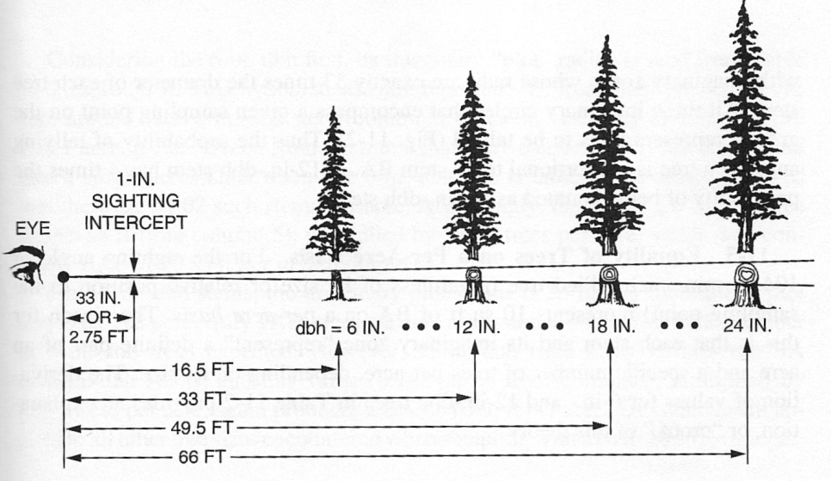
Figura 2 Tamaño del árbol y limitación de distancias para medir un ángulo 1:33 con prisma

Para una mejor comprensión se puede observar en la figura 3 áreas o zonas imaginarias proporcionales al área basal (área de influencia) y cada una de estas determina que árboles entran en el muestreo. Así mismo, árboles C, D, E, y F se consideran “dentro” de la muestra y son tomados en cuenta en el punto de muestreo:
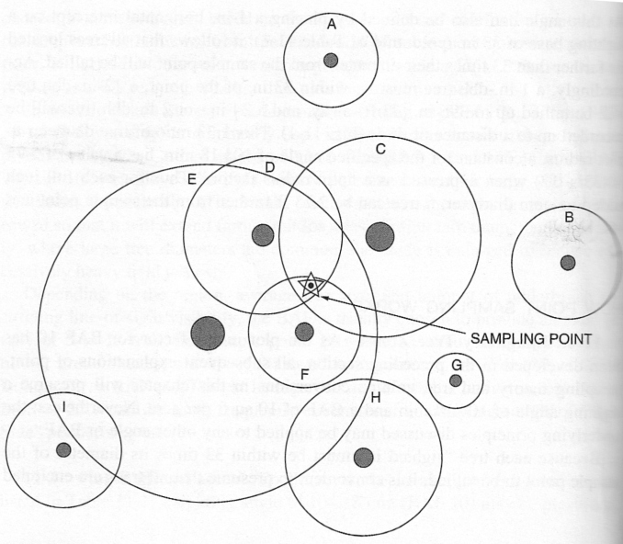
Figura 3 Areas imaginarias proporcionales al tronco de los arboles (area basal) y determinacion de los arboles “dentro” a evaluar
De igual manera, en el siguiente ejemplo, los árboles 1, 3, 6 y 8 están “dentro” de la muestra y se registran en el punto de muestreo (figura 4):

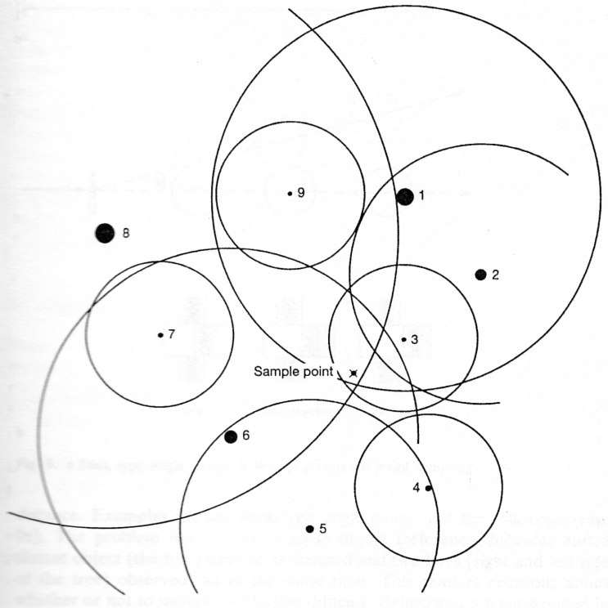
Figura 4 Selección de los árboles en el punto de muestreo
Para coordinar la implementación del muestreo y evitar contar un árbol dos veces, es necesario marcar el primer árbol con cinta marcadora (naranja) y proceder a realizar un barrido del bosque en 360 grados con el prisma en una misma dirección, siguiendo o contra la dirección de las agujas del reloj.
Para una mejor comprensión la figura 5 muestra en una vista desde arriba como seria el barrido del bosque con el prisma desde el punto de muestreo identificándose a los árboles que estarían “dentro” de la muestra.
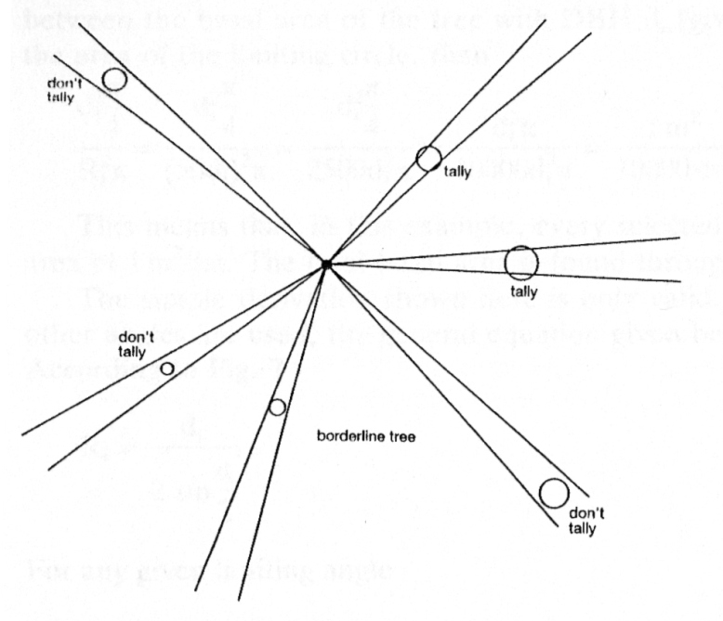
Figura 5 Punto de muestreo (centro)
B. Determinación de árboles “dentro” mediante prisma

Para una correcta utilización del prisma es necesario considerar los siguientes casos (figura 6):
- En el caso de la izquierda (figura 6a), la imagen del prisma no intercepta al árbol, por lo que en este caso el árbol no es registrado.
- En el caso del medio (figura 6b), la imagen del prisma intercepta al árbol, por lo que árbol es tomado en cuenta.
- En el caso de la derecha (figura 6c), la imagen del prisma es totalmente tangente al árbol siendo este un árbol limite, por lo que es necesario medir la distancia entre el árbol y el punto de muestreo, verificando así, si esta distancia es menor que la distancia límite del prisma según su BAF y de esta manera confirmar si el árbol se incluye o no dentro de la muestra.
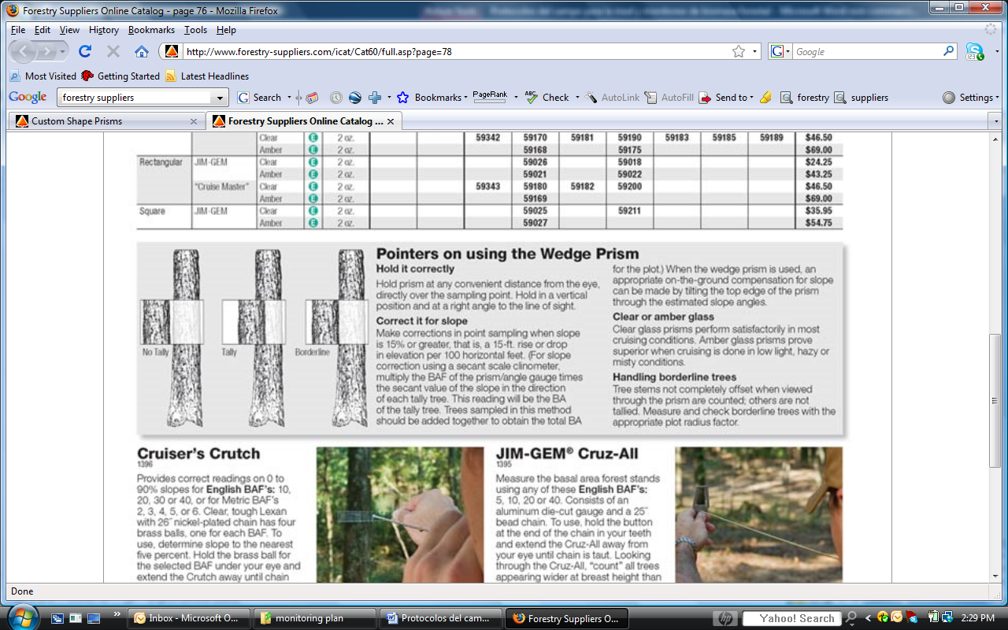
c
a
b
Figura 6 Vista de los árboles con el prisma, determinación de árboles “dentro” a tomar en cuenta en el muestreo
Es de gran importancia tomar las siguientes precauciones para evitar errores personales:
1) el perfil de cada árbol debe verse al nivel del pecho; un asistente puede colocar una hoja de papel blanco a este nivel o de otro modo colocar un jalon con cinta marcadora a la altura del DAP para poder ser observado en el prisma
2) los árboles inclinados deben ser vistos con el prisma observando al diámetro de manera perpendicular al eje central del fuste, de la misma manera el jalon con la cinta marcadora deberá ser colocada en forma inclinada como se explico anteriormente
3) el prisma debe de ser ubicado en el punto central de la parcela durante el barrido (giro) salvo cuando se avisten árboles escondidos. Cuando el dosel dificulte la observación utilizarse la cinta forcípula o diamétrica y el DME para determinación de la distancia y el DAP.
4) la línea de visión a la altura del pecho debe ser horizontal o una corrección de pendiente debe usarse, mediante la utilización de clinómetro
5) Debe tenerse cuidado al ver árboles escondidos o parcialmente escondidos detrás de un árbol cercano. Si es necesario, el prisma puede ser desplazado a una lado, no más de 1 o 2 metros, con tal que la distancia al árbol no se altere.
6) Debe tenerse cuidado para ver siluetas individuales y separarlas de la sobreposición de los vecinos.
7) El conteo debe ser hecho sin error, los puntos de inicio deben ser marcados así como los arboles ya contados. Es fácil olvidarse la cuenta.
8) Los árboles límite deben ser verificados matemáticamente utilizando la cinta diamétrica y el DME y registrarlo en el formato columna “Solo Limites y no visibles”
9) Un factor de conteo para dar una cuenta de entre 5 a 10 árboles es a menudo recomendado. (Algunos libros sugieren conteos mayores, pero creo que erróneamente. Observadores inexpertos obtienen resultados más consistentes con factores altos que contar menos de 5 árboles por barrido.
Además en condiciones de sotobosque denso y baja visibilidad es necesario tomar en cuenta lo siguiente:
- Uso preferido de prisma de BAF 40, excepto en casos en que haya menos de 5 registros por punto de muestreo
- El barrido alrededor del punto de muestreo por 2 personas, quienes:
- Vigilan por arboles grandes que queden lejos y no visibles del punto de muestreo; en el caso de encontrar arboles no visibles del punto de muestreo, que posiblemente deben ser registrados, se mide el diámetro y la distancia del punto, igual como estuvieran interpretados como arboles limite, para evaluar luego en gabinete
- Facilitan las observaciones por el prisma, moviendo o, en limitados casos, cortando follaje que quede entre el punto de muestreo y un árbol evaluado
- Facilitan las interpretaciones visuales por el prisma, poniendo papel blanco y/o un palo con cinta roja justo al lado del fuste
- Preferentemente el día de trabajo en campo debe terminarse a una hora antes de que oscurezca pues las observaciones en este horario son dificultosas utilizando el prisma (a las 16:30 o 17:00), además la distancia del punto ha de ser considerada para el tiempo en el campo.
C. Utilización del Prisma

Para una correcta utilización del prisma es necesario considerar los siguientes casos (figura 7):
- Caso A, forma correcta de mantener el prisma durante la observación, manteniéndolo en el plano vertical, con la base del prisma paralela al suelo.
- Casos B y C son incorrectos (excepto en casos de observar árboles inclinados o en casos de pendientes mayores a 15% (ver abajo)).
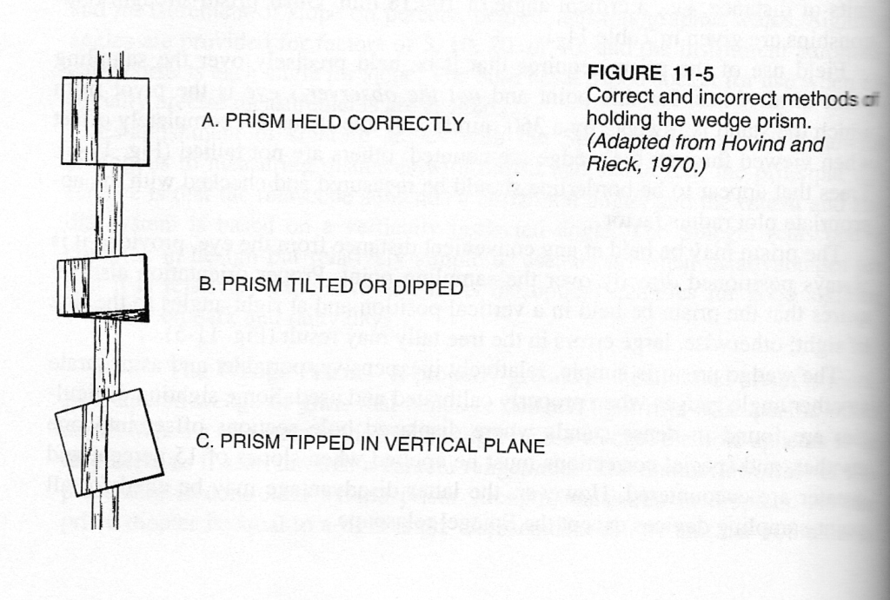
Figura 7 Correcta e incorrecta forma de sostener el prisma
El prisma se mantiene orientado siempre en un ángulo perpendicular al ángulo de vista. En los casos en que la pendiente del terreno excede al 15%, se gira indistintamente a la izquierda o a la derecha, el prisma en el plano perpendicular al ángulo de vista, un ángulo igual al ángulo de la pendiente para corregir los errores por pendiente; este ángulo se mide con un clinómetro (figura 8). Esto efectivamente reduce el BAF y da una imagen simulando la imagen que se genera en la distancia horizontal.
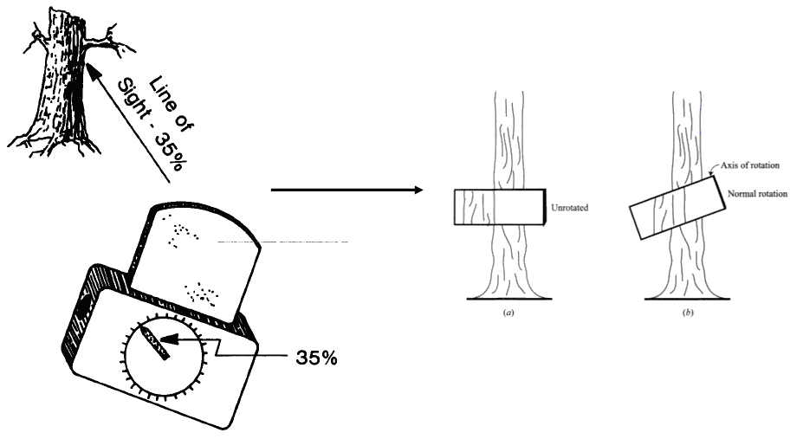
Figura 8 Corrección por pendiente con uso de Clinómetro
Otro método que ha de ser tomado en cuenta es “método de espejismo” (figura 9) para el caso de puntos de muestreo que se encuentran cerca del borde del bosque. Se mide la distancia del punto de muestreo al borde del bosque, y una distancia igual “se refleja” fuera del bosque para agregarle otro punto de muestreo (el mismo árbol se puede registrar dos veces).
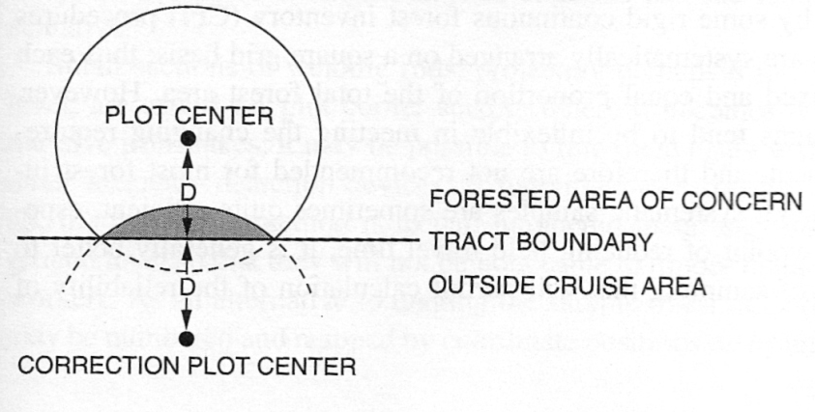
Figura 9 Método de espejismo para corrección por bordes de bosque
D. Medición del diámetro a la altura del pecho (DAP)

A los árboles tomados en cuenta en la muestra por el prisma, se les mide el diámetro a la altura del pecho (DAP) a una altura de 1.3 m por encima del suelo con una cinta diamétrica o forcípula. Solamente se medirán los árboles que tengan un DAP mayor o igual a 5 cm.
A continuación se muestran las diferentes situaciones que se pueden encontrar para medir el DAP (Pancel, 1993).

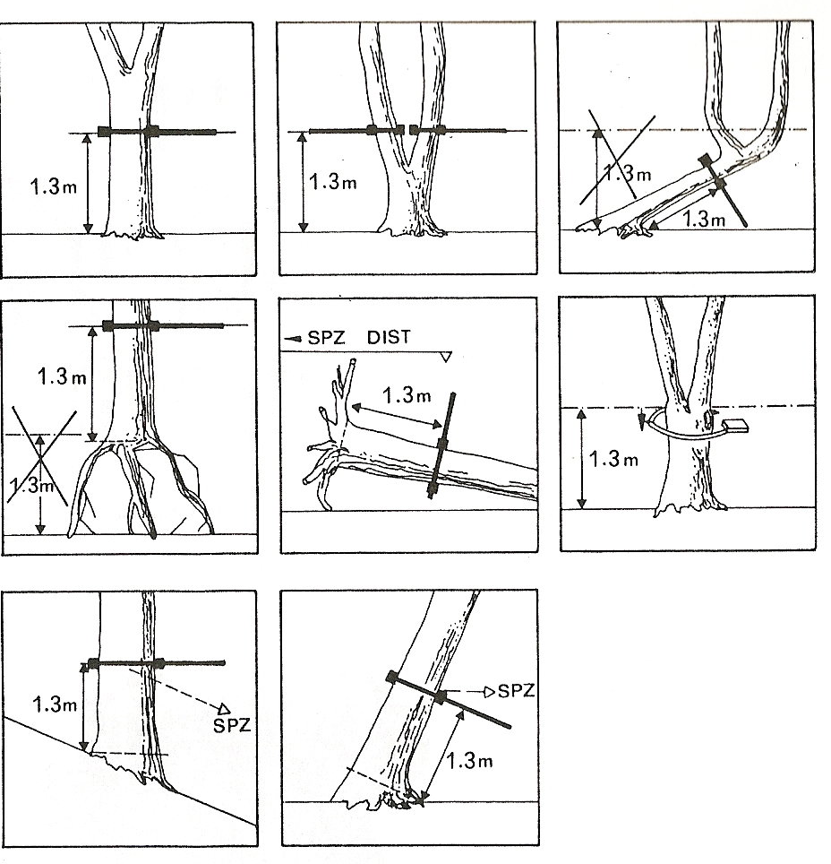
En los casos de árboles con contrafuertes o aletas, se mide el diámetro a 30 cm por encima del término de los contrafuertes o aletas. En el caso de las palmeras, se miden el diámetro basal y la altura de fuste.
E. Medición de la altura de árboles y palmas

La medición de alturas será realizada solamente para árboles muertos en pie y palmas. Para esto debe considerarse lo siguiente:
- En terrenos planos
- Para la medición en este tipo de terreno es importante que el observador tenga ya medida la altura desde el suelo hasta su ojo en metros.
- Mediante la utilización del clinómetro se estima el porcentaje (%) al punto de copa del árbol desde un punto cualquiera, de preferencia “punto central”.
- Mediante el uso del telémetro láser, DME o cinta métrica se medirá la distancia horizontal desde el punto del observador al árbol en metros.

- En terrenos con pendiente:
- Para la medición en este terreno el observador deberá colocarse en pendiente de preferencia bajo del árbol.
- Se estima con el clinómetro un porcentaje (%) que va del observador a la base del árbol denominado θ₁
- Luego se estima con el clinómetro otro porcentaje (%) que va del observador al punto de copa del árbol denominado θ₂.
En el caso de palmas se deberá medir con clinómetro utilizando el mismo criterio que con los árboles hasta el punto donde parten las hojas.
Solo en casos donde no se puede observar con el clinómetro deberá optarse por la medición estimada al “ojo” en metros de la altura al punto de copa del árbol.
IV. MEDICIÓN DE LA MADERA MUERTA EN PIE
La madera muerta en pie es muestreada de igual manera que los árboles vivos, en las mismas parcelas de radio variable y se las mide con los prismas. Se asigna la madera muerta en pie a una de estas dos categorías:
- De igual estructura que un árbol vivo (aun con presencia de ramas finas), salvo la ausencia de hojas.
- Con señales de descomposición aparentes, como pérdida de ramas o de la copa entera.
Para la categoría 1, se mide el DAP igual que los árboles vivos. Para la categoría 2, se mide el diámetro basal y la altura de fuste, y se asigna a una de las categorías de descomposición (descritas más adelante).

V. MEDICIÓN DE LA MADERA MUERTA CAÍDA

La madera muerta caída se define como las trozas con un diámetro mínimo de 10 cm, y que tengan más de 50% de su masa o volumen por encima del nivel del suelo.

Se asigna a la madera muerta uno de los tres estados de densidad o de descomposición: sólido, intermedio o podrido, según la “prueba de machete”. Esta prueba consiste en golpear la troza con el canto del machete, si el machete no se hunde en la troza (rebota) se clasifica como sólida. Si el machete se hunde parcialmente en la troza y ha habido pérdida de madera, se clasifica como intermedia. Si el machete se queda “pegado” a la troza, la pérdida de madera es más extensa y si la troza se desmorona, entonces se clasifica como podrida.

Se recomienda que el muestreo de madera caída se hace antes del muestreo de arboles en pie para evitar que se pisen las trozas antes del muestreo. Se muestrea madera caída según el método “line intersect” o intersección con línea (Warren y Olson 1964, Van Wagner 1968, Harmon y Sexton 1996). Se establecen dos líneas de 50 metros (o sea un muestreo de 100 metros en total) que se atraviesan en el mismo punto de muestreo utilizado con los prismas. La primera línea sigue un azimut escogido al azar, y el segundo se orienta de manera perpendicular al primero (ver la figura abajo). Se mide y anota el pendiente de cada línea, si exceden el 15%.

Caminando el largo de las líneas, se miden y anotan para todos las trozas que cruzan las líneas (1) el diámetro en el punto de intersección, (2) estado de descomposición, y si existe un hueco, (3) el diámetro del hueco. Sólo debe medirse la troza si la línea de muestreo cruza por lo menos 50% del diámetro de la troza. Se recomienda el uso de forcípulas en vez de cinta diamétrica para medir los diámetros por facilidad y seguridad de uso (no hay que pasar la cinta debajo de las trozas).
50m
50m
Punto de muestreo
Figura 10 Método intersección con línea para madera muerta caída
A. Muestreo para determinación de la densidad de madera muerta

Durante las mediciones de campo, se deben recolectar muestras de madera muerta de cada clase de densidad para calcular, posteriormente, su peso específico. Estos resultados se utilizarán para estimar la biomasa y el carbono a partir de las mediciones de campo. Un mínimo de 30 muestras de madera muerta serán recolectadas por cada clase de densidad, lo cual dará un número total de 90 muestras. Se corta un disco completo de la pieza seleccionada de madera muerta usando una sierra de cadena o un serrucho manual. Medir el diámetro promedio (L1 y L2) y el espesor (T1 y T2) en cm (como se muestra en la siguiente figura). El disco debe ser colocado en una bolsa de papel, y luego secado en horno (80º C) en el laboratorio a un peso constante.
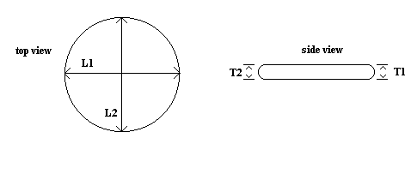

FUENTES
Fuentes generales de dasometría y muestreo por parcelas de radio variable:
Avery, T.E. and H.E. Burkhart. 1994. Forest Measurements. Fourth Edition. McGraw Hill, Boston, Massachusetts, USA. 408 pp.

Husch, B., Beers, T. and J. Kershaw. 2002. Forest mensuration.

Pancel, L., ed. 1993. Tropical forestry handbook. Berlin, Germany, Springer-Verlag. 1 738 pp. (Two volumes)
Philip, M. S. 1994. Measuring Trees and Forests. Second Edition. University Press, Cambridge, UK. 310 p.

Sobre eficacia comparativa de muestreo por parcelas de radio variable:
Grosenbaugh, L. and W. Stover. 1957. Point-sampling compared with plot-sampling in southeast Texas. Forest Science 3:2-14.
Schreuder, H., Banyard, S. and G. Brink. 1987. Comparison of three sampling methods in estimating stand parameters for a tropical forest. Forest Ecology and Management 21:119-127.
Sobre el método “line intercept” para madera caida:
Harmon, M.E. and J. Sexton. (1996) Guidelines for measurements of wood detritus in forest ecosystems. US LTER Publication No. 20. US LTER Network Office, University of Washington, Seattle, WA, USA.

Warren, W.G. and Olsen, P.F. (1964) A line intersect technique for assessing logging waste. Forest Science 10: 267-276.

Van Wagner, C.E. (1968). The line intersect method in forest fuel sampling. Forest Science 14: 20-26.

FORMULARIO TOMA DE DATOS PARA MEDICIÓN DE BIOMASA FORESTAL: PARQUE NACIONAL CORDILLERA AZUL
Cluster-Punto:_____Estrato:__________ Sector: DATUM: UTM N: UTM E:
Pendiente (si > 15%): _____ (grados o porcentaje) Fecha:________Hora de inicio y termino:__________/ Datos tomados por:_______
Notas:
MEDICIÓNES DE ÁRBOLES VIVOS Y MADERA MUERTA EN PIE POR MUESTREO POR PARCELAS DE RADIO VARIABLE:
BAF de prisma (ft²/acre):
Especie o clase de madera muerta en pie | DAP  (cm) | Solo limites | Solo para palmas y madera muerta en pie (categoría 2)
Especie o clase de madera muerta en pie | DAP  (cm) | Solo limites | Diámetro basal  (cm) | Para altura
Especie o clase de madera muerta en pie | DAP  (cm) | Dist. al punto  (m) | Diámetro basal  (cm) | Dist.  (m) | Angulo (grados)y metros
 |  |  |  |  | Θ₁ | Θ₂ | metros
MADERA MUERTA CAÍDA POR MUESTREO DE INTERSECCION CON LINEA:
Pendiente (grados o porcentaje) de línea 1:__________ ____
y línea 2:__________
Diámetro  (cm) | Estado de descomposición (S, I, P) | Diámetro del hueco, si hay  (cm)

foto | azimut | observaciones

Citations
Anderson, L.O., Malhi, Y., R. J. Ladle, L. E. O. C. Aragao, Y. Shimabukuro, O. L. Phillips, T. Baker, A. C. L. Costa, J. S. Espejo, N. Higuchi, W. F. Laurance, G. Lopez-Gonzalez, A. Monteagudo, P. Nunez Vargas, J. Peacock, C. A. Quesada, and S. Almeida. 2009. Influence of landscape heterogeneity on spatial patterns of wood productivity, wood specific density and above ground biomass in Amazonia. Biogeosciences 6: 2039-2083.
Avery, T.E. and H.E. Burkhart. 1994. Forest Measurements. Fourth Edition. McGraw Hill, Boston, Massachusetts, USA. 408 pp.
Baker TR., Phillips OL., Malhi Y., Almeida S., Arroyo L., Di Fiore A., Killeen TJ., Laurance SG., Laurance, WF., Lewis SL., Lloyd J., Monteagudo A., Neill DA., Patiño S., Pitman NC., Silva JN., Vásquez Martínez R. Variation in wood density determines spatial patterns in Amazonian forest biomass. Global Change Biology. 2004; 10:545-562.
Brown, S. 1997. Estimating biomass and biomass change of tropical forests: a primer. FAO Forestry Paper 134, Rome, Italy
Cairns, M. A., S. Brown, E. H. Helmer, and G. A. Baumgardner. 1997. Root biomass allocation in the world’s upland forests. Oecologia 111, 1-11.
Chave, J., Andalo, C., Brown, S., Cairns, M.A., Chambers, J.Q., Eamus, D., Folster, H., Fromard, F., Higuchi, N., Kira, T., Lescure, J.P., Nelson, B.W., Ogawa, B., Puig, H., Riera, B. and T. Yamakura. 2005. Tree allometry and improved estimation of carbon stocks and balance in tropical forests. Oecologia 145:87-99.
Delaney, M., Brown, S. and M. Powell. 2000. 1999 Carbon-Offset Report for the Noel Kempff Climate Action Project, Bolivia. The Nature Conservancy.
Freitas Alvarado, L., Otorola Acevedo, E., del Castillo Torres, D., Linares Bensimon, C., Martinez Davila, P. and G.A. Malca Salas. 2006. Servicios Ambientales De Almacenamiento Y Secuestro De Carbono Del Ecosistema Aguajal En La Reserva Nacional Pacaya Samiria, Loreto, Perú. Instituto de Investigaciones de la Amazonía Peruana. Documento Técnico Nº 29. Iquitos, Perú.
Harmon, M. E. and J. Sexton. 1996. Guidelines for Measurements of Woody Detritus in Forest Ecosystems. US LTER Publication No. 20. US LTER Network Office, University of Washington, Seattle, WA, USA.
IPCC 2006 Guidelines for National Greenhouse Gas Inventories. Chapter 4 AFOLU (Agriculture, Forestry and Other Land-use).
Malhi Y., Wood D., Baker TR., Wright J., Phillips OL., Cochrane T., Meir P., Chave J., Almeida S., Arroyo L., Higuchi N., Killeen TJ., Laurance SG., Laurance WF., Lewis SL., Monteagudo A., Neill DA., Núñez Vargas P., Pitman NC., Quesada CA., Salomão R., Silva JN., Lezama AT., Terborgh J., Vásquez Martínez R., Vicenti B. The regional variation of aboveground live biomass in old-growth Amazonian forests. Global Change Biology. 2006; 12: 1–32.
Van Wagner, C.E. (1968). The line intersect method in forest fuel sampling. Forest Science 14: 20-26.
Warren, W.G. and Olsen, P.F. (1964) A line intersect technique for assessing logging waste. Forest Science 10: 267-276.

Commercial volume equation used in Acre, Brazil (source: Igor Agapejev, TECMAN, Rio Branco, Acre, Brazil).
J. Chave, H. Muller-Landau, T. Baker, T. Easdale, H. ter Steege, CO Webb. 2006. Regional and phylogenetic variation of wood density across 2,456 neotropical tree species. Ecological Applications 16, 2356-2367.

